Configuration Guide for AWS EKS integration with AWS code pipeline.:

Required tools and Services:
- AWS account, GitHub Account (code commit).
- Docker based application source code.
https://github.com/ vamsi-devops/aws_pipeline_demo.
- Services used in AWS is (ECS, ECR, IAM, Code Build, Code Deploy, Code Pipeline).
- Cloud connect access and admin rights access (Applicable from Infosys network only).

Contents
1 EKS Setup:
1.1 Create IAM User & VPC: 7
1.2 Create repository in ECR. 8
2 CI/CD implementation:
2.1 Code Build 12
2.1.1 Push image to ECR.
2.2 Create Ec2 instance …………………………………………………………………………………………………….13
2.3 Code Deploy. 17
2.4 Code Pipeline ……………………………………………………………………………………………………………21
2.5 EKS Cluster formation………………………………………………………………………………………………….22
2.6 Output…………………………………………………………………………………………………………………………23

  - VPC & IAM User Creation:

VPC CREATION STEP BY STEP

By default, if we create the VPC we will get
- Route Table
- NACL
- SG (security group)

STEP1:
- Assign a tag name for VPC
- Take CIDR value as per your requirement (ex: 192.168.0.0/16)
- VPC has been created as per the requirement

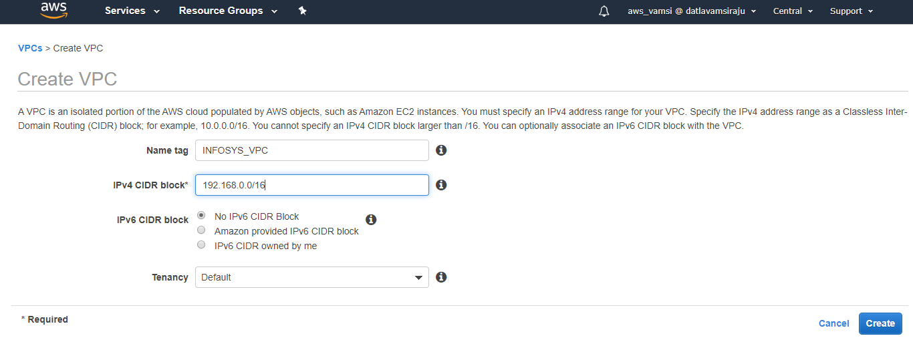

STEP2:
- Create IGW and assign a tag name.

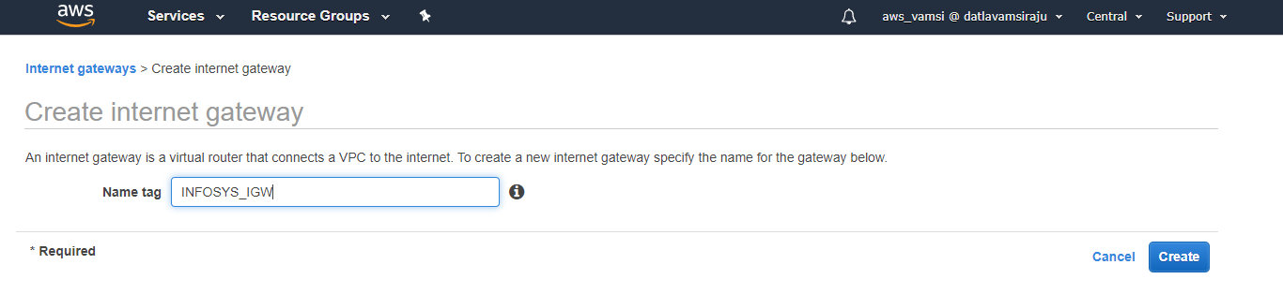
STEP3:

- Attach IGW to VPC to give public access to the VPC.

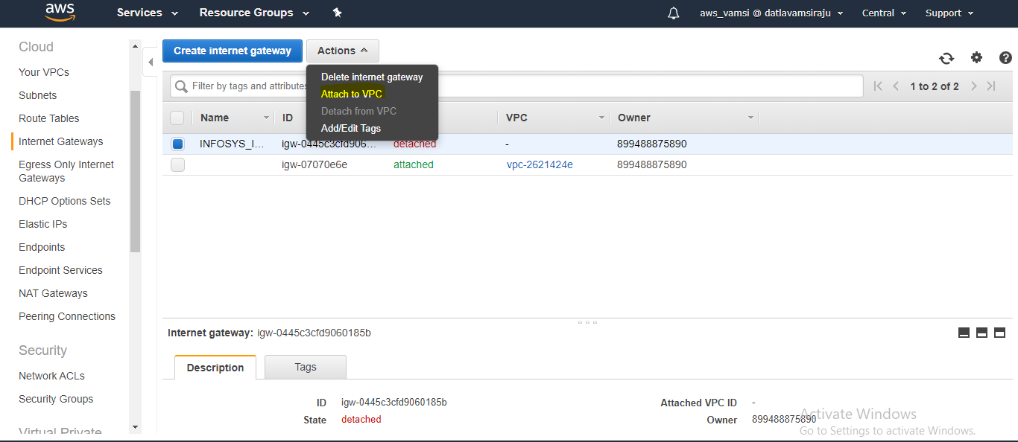

STEP4:

- IGW has been attached to the VPC.
- Now the isolated VPC has been exposed to public.

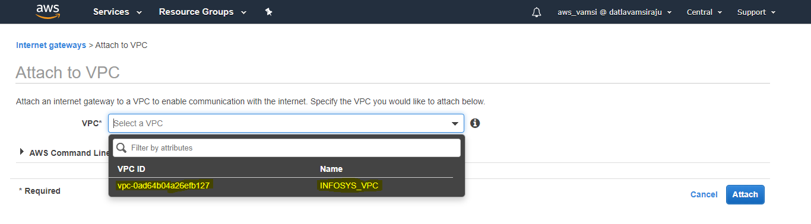

STEP5:
- After VPC creation and IGW attached to the VPC we have to create the SUBNET’S
1st subnet is for public
2nd subnet is for private
- The below are the required details for creating SUBNET1 well as SUBNET2

SUBNET1:
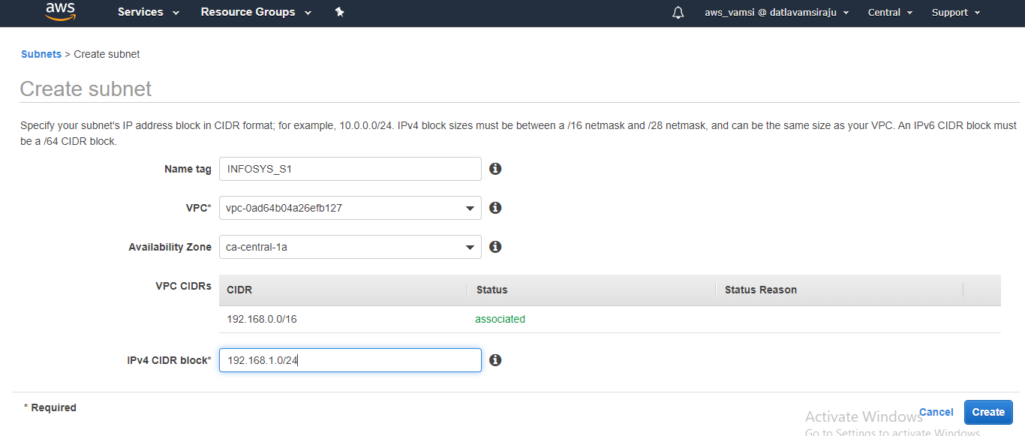

SUBNET2:
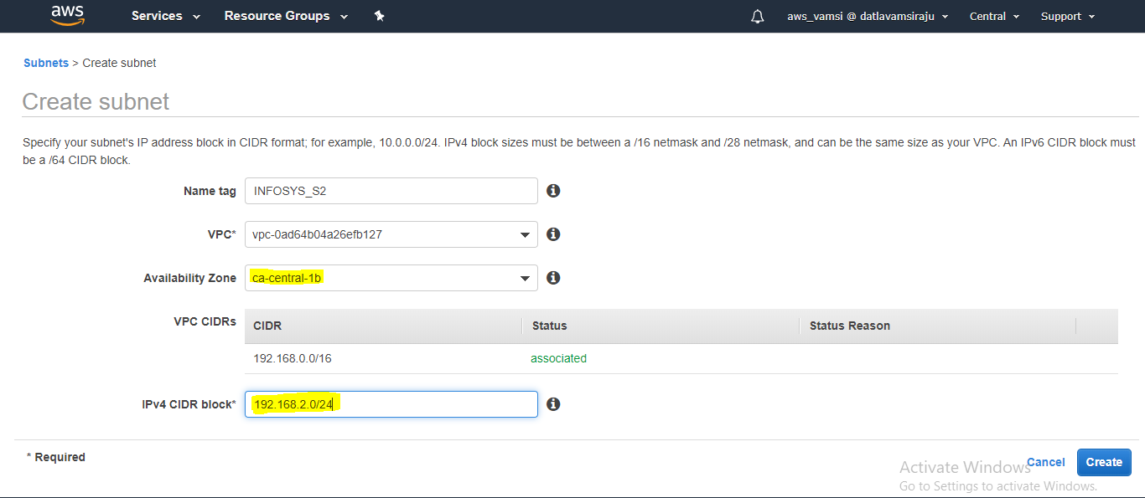

STEP6:
- Assign SUBNET to the Route table.
- Subnet1 is assigned to public route table.
- Subnet2 is assigned to private route table.

Public route table assigned to public subnet:

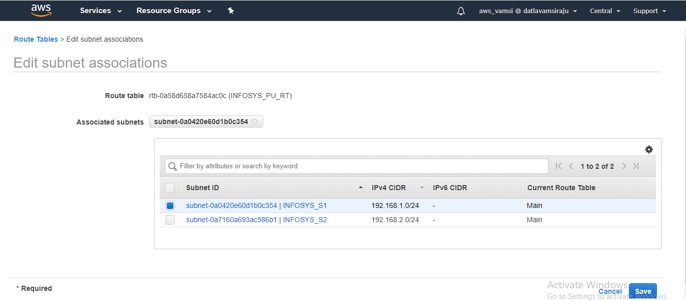

Private route table assigned to private subnet:

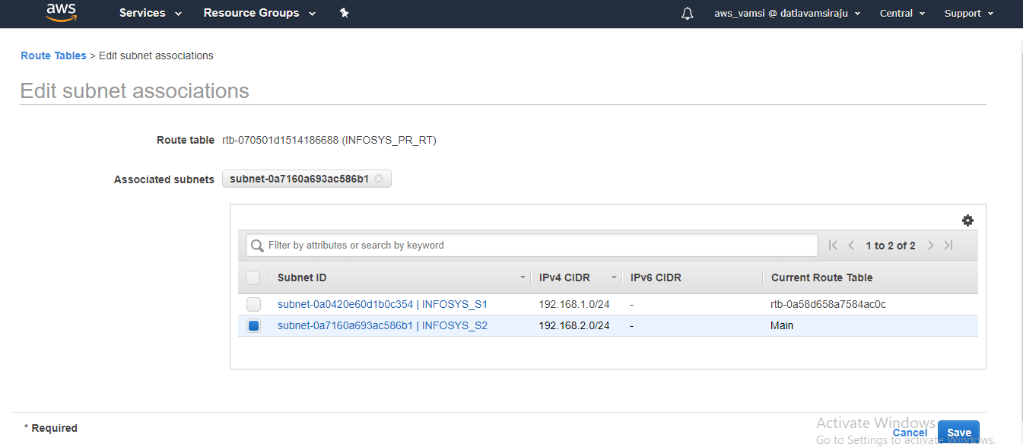

STEP7:
- Need to attach IGW to Route table.
- Only when you attach IGW then the Route table and attached Subnet will act as public.

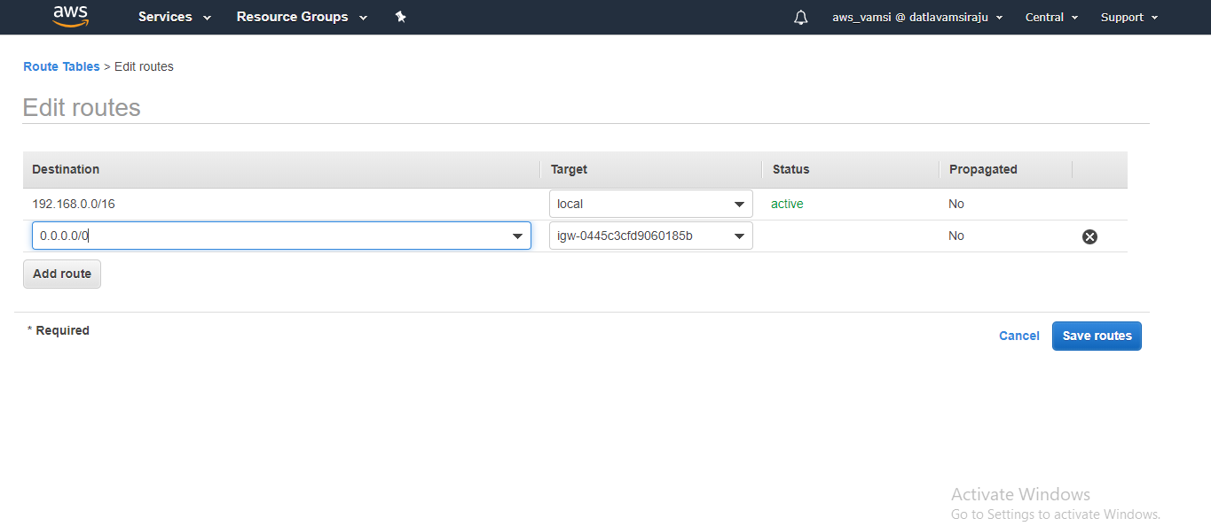

STEP8:

- NAT gate way is a bridge between Private Route table and internet.
- Once NAT is connected to the route table the private route table will be connected to internet.

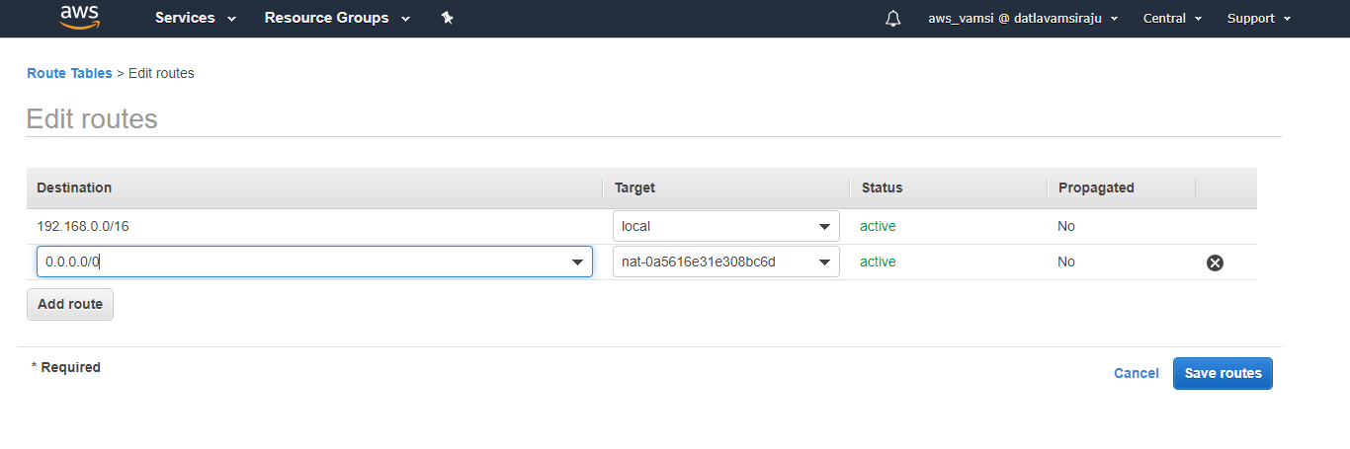
  - Create an ECR repository:

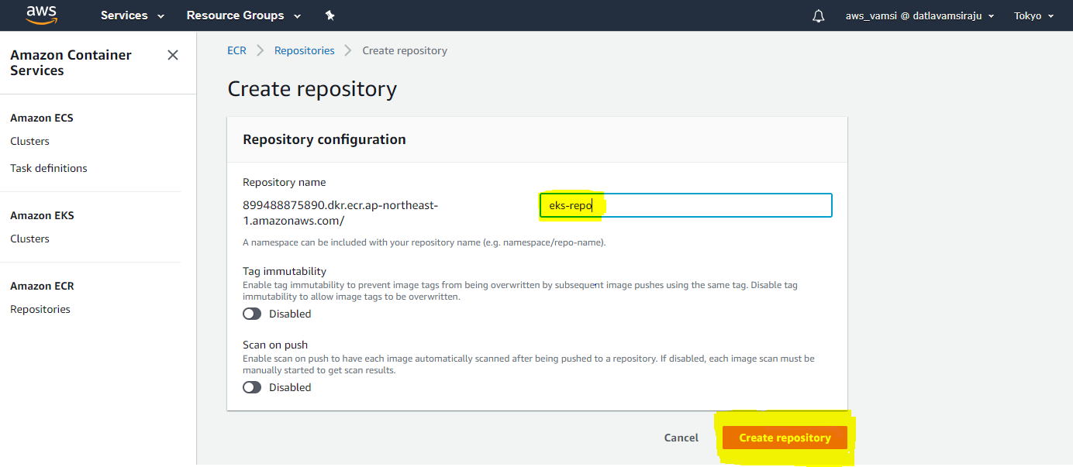

Give a name to ECR repository and create it in my case I have given EKS-repo.

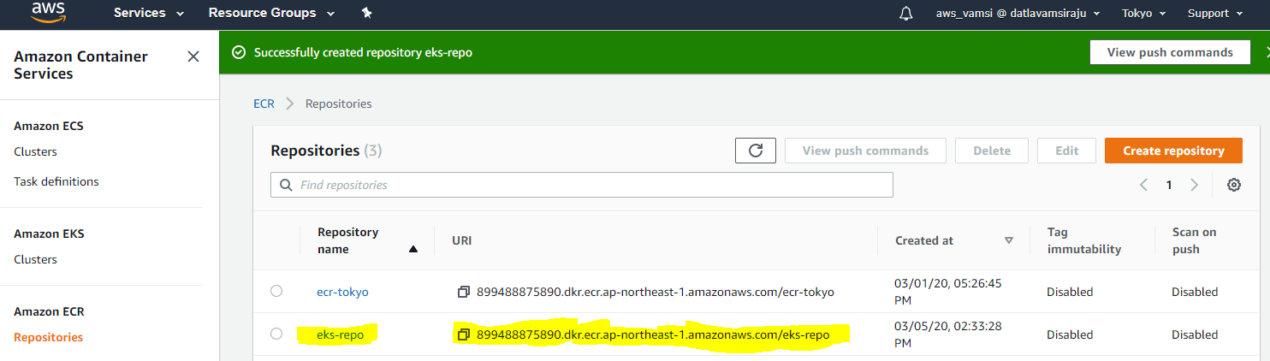
- After creating ECR Repository create a Build project in Code Build
Create build project.

2.1 Code Build:

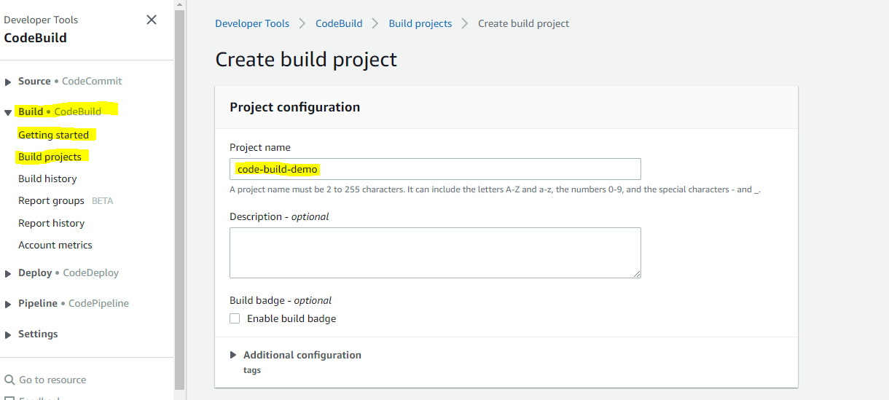

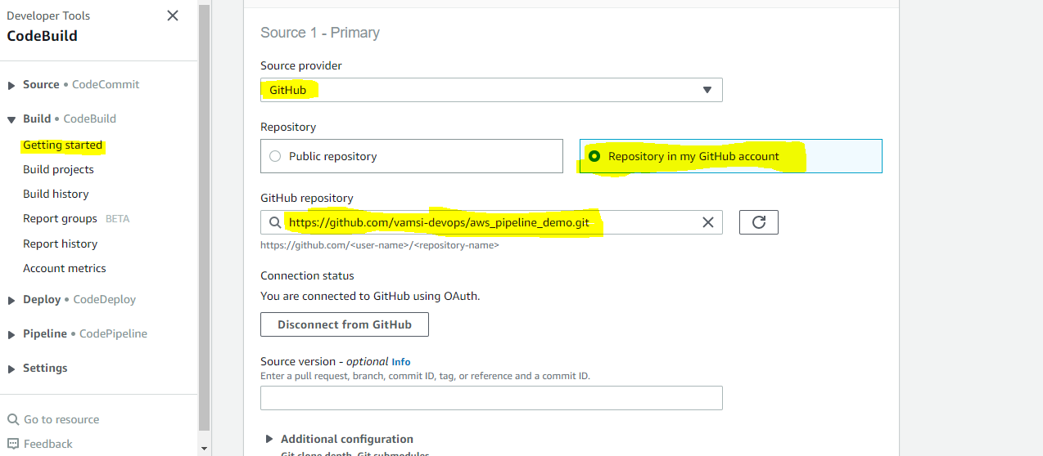

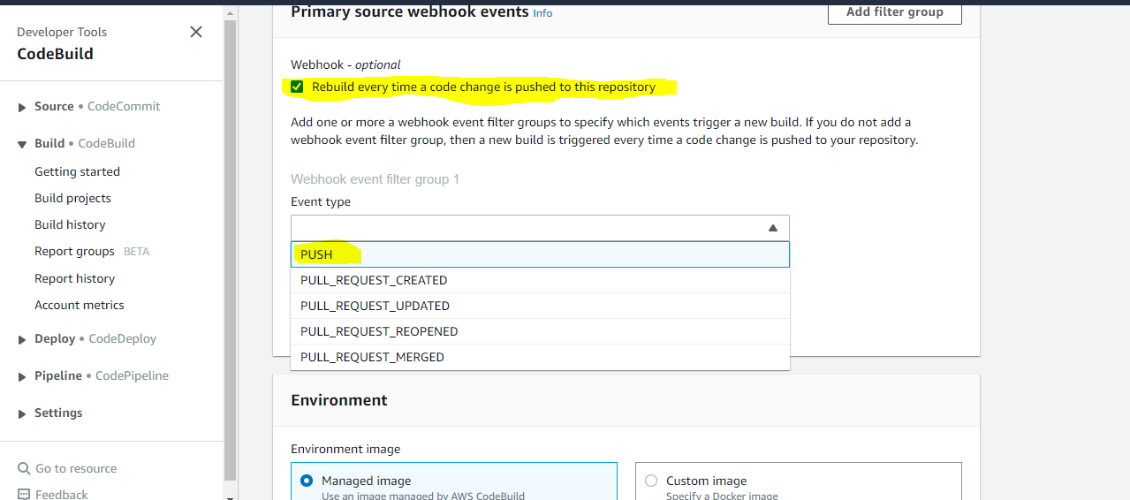

Here we will give a Debian/RedHat instance for building the image.

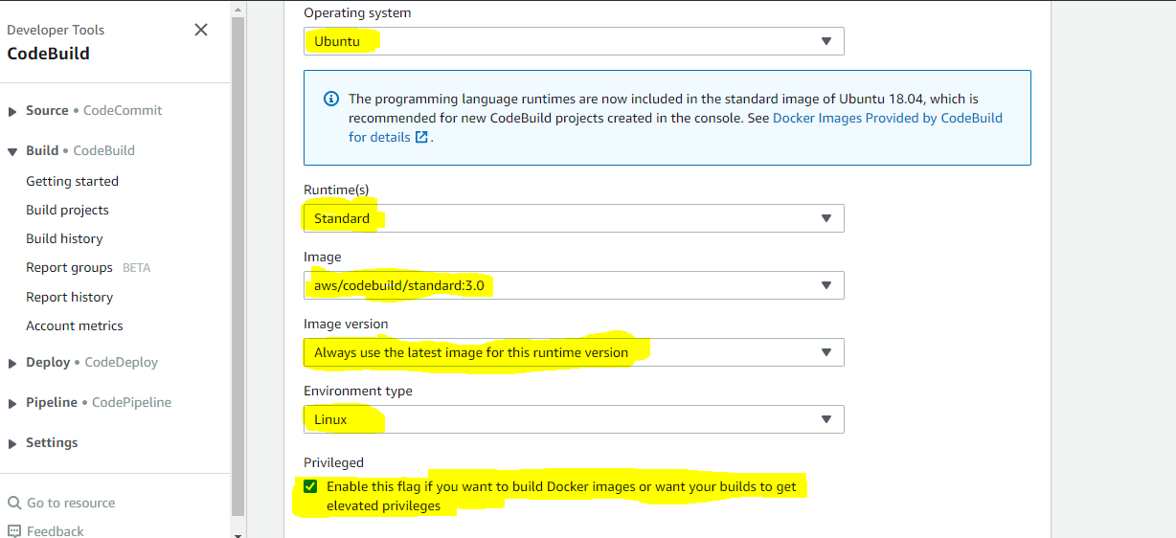

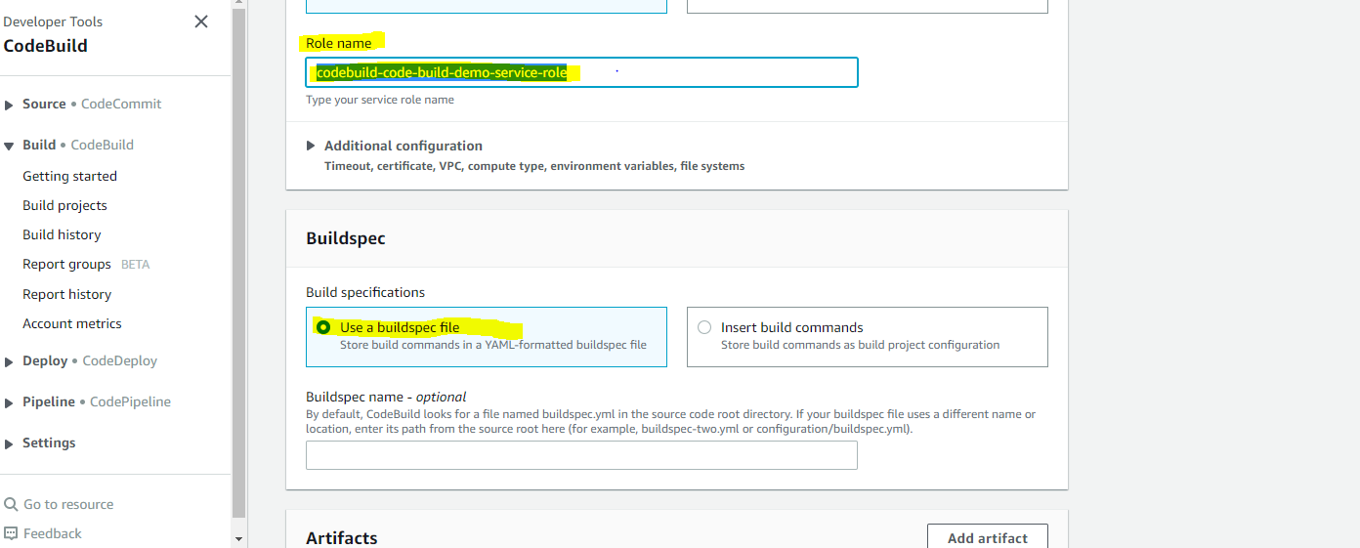

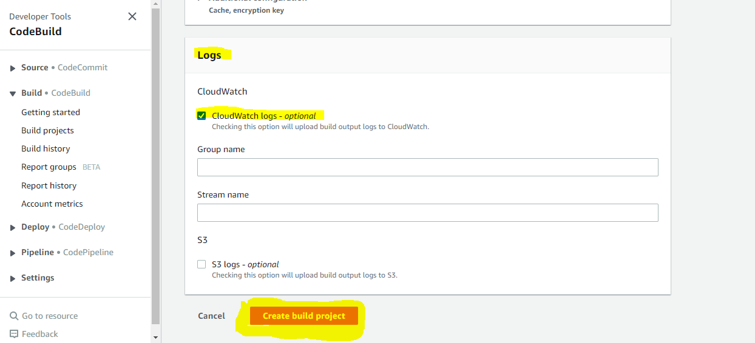

Successfully created a Code Build.

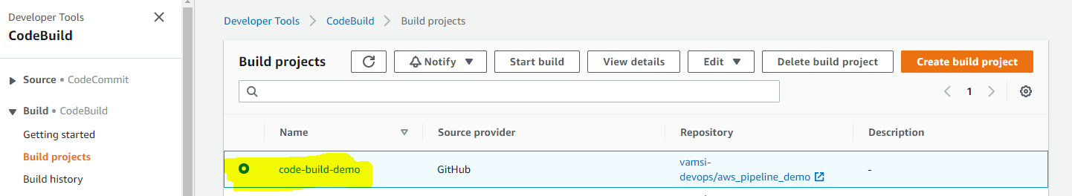

- Create a same IAM role which you given in Code build and attach a AmazonEC2ContainerRegistryFullAccess Policy to the service role for pushing the images into the ECR registry.

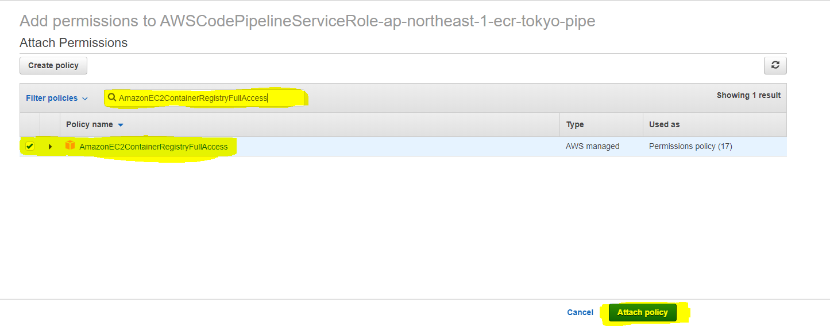

2.2 Create an Ec2 Ubuntu Instance and make sure to Install AWS CLI 2.0 & Ruby:

Install the Code Deploy agent on the node now by following the below steps:
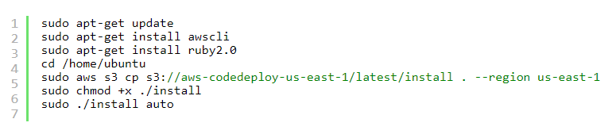

- And create IAM role and attach full Administrator access policy to the role and attach that role to the instance.
To check whether the Code Deploy agent working or not.

# sudo service codedeploy-agent status

2.3 Create a Code Deploy:

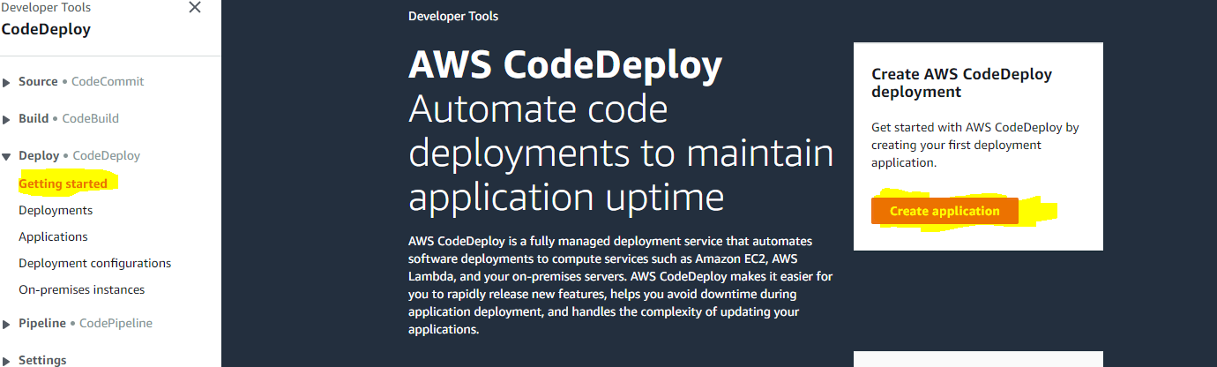

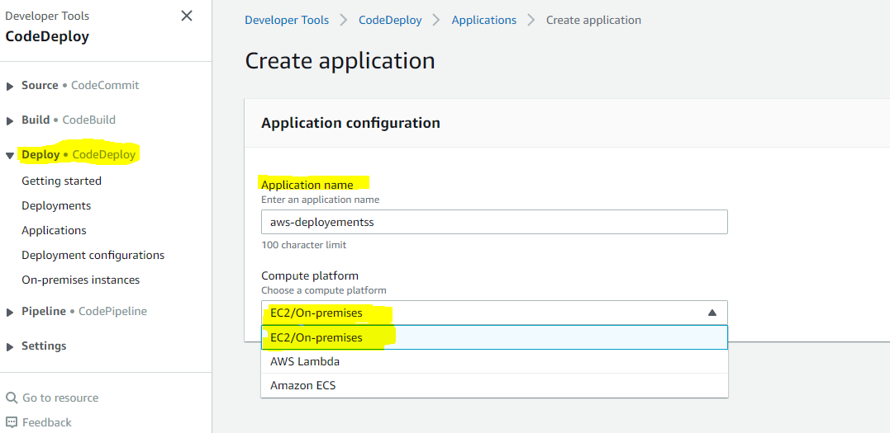

- After creating Application create the deployment group.

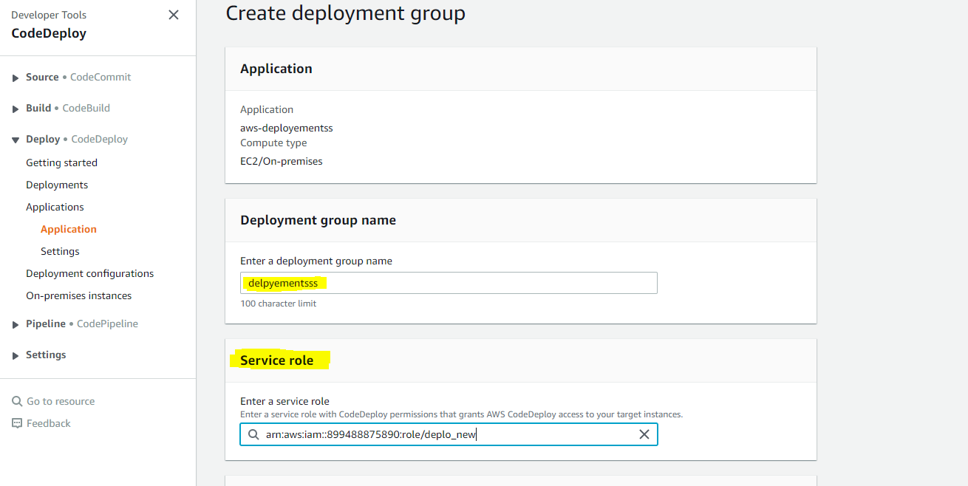

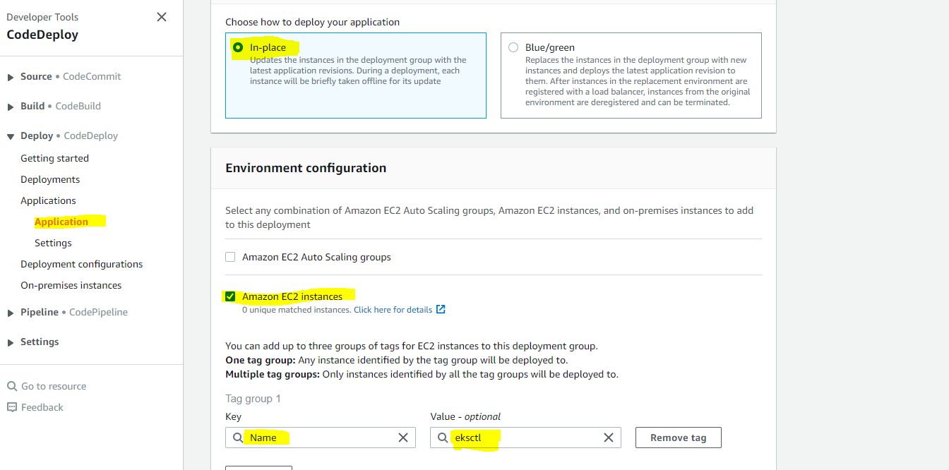

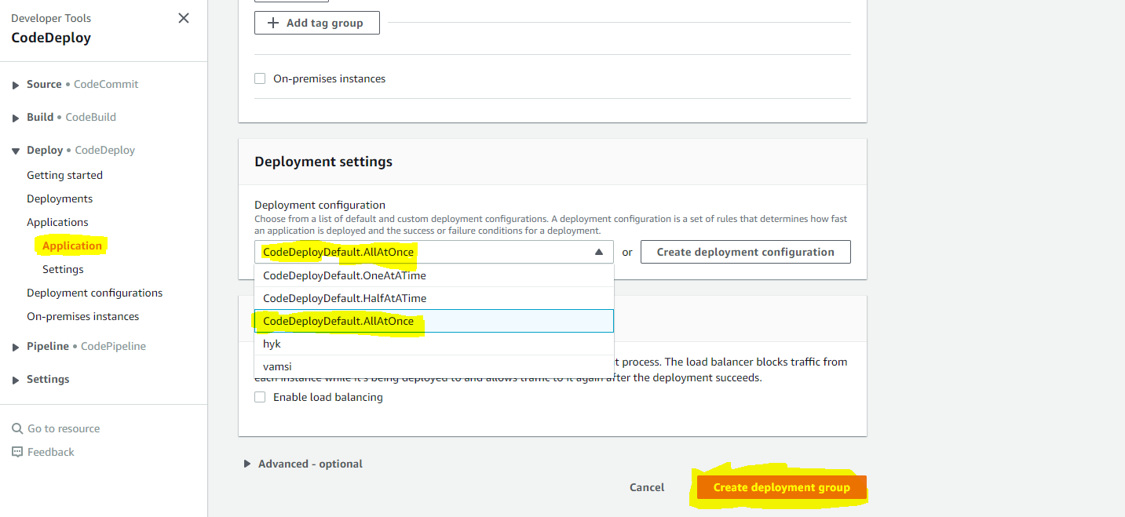

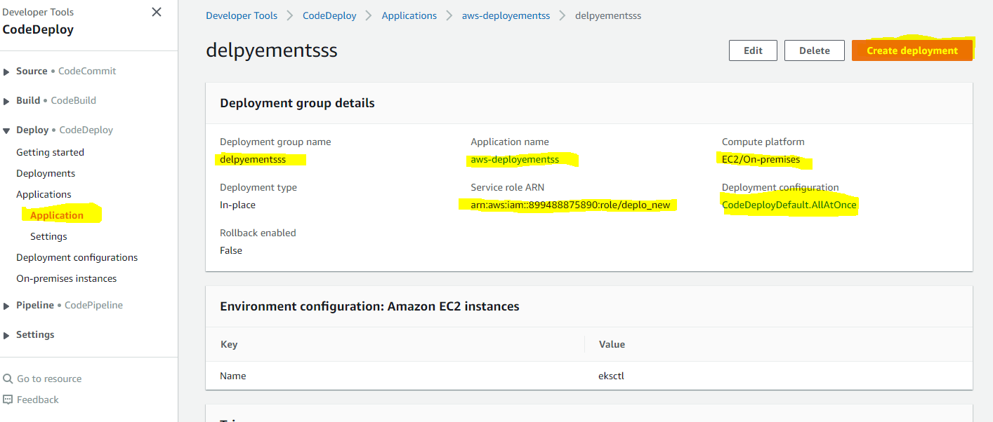

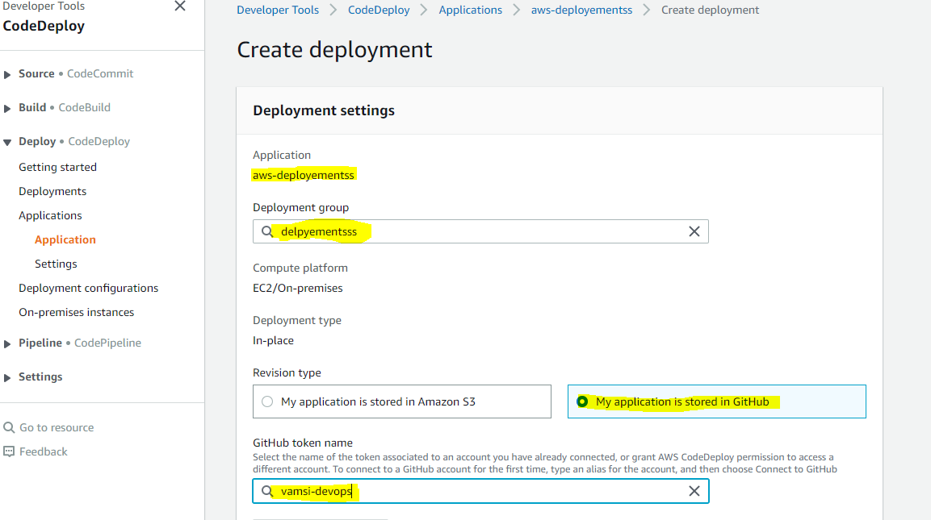

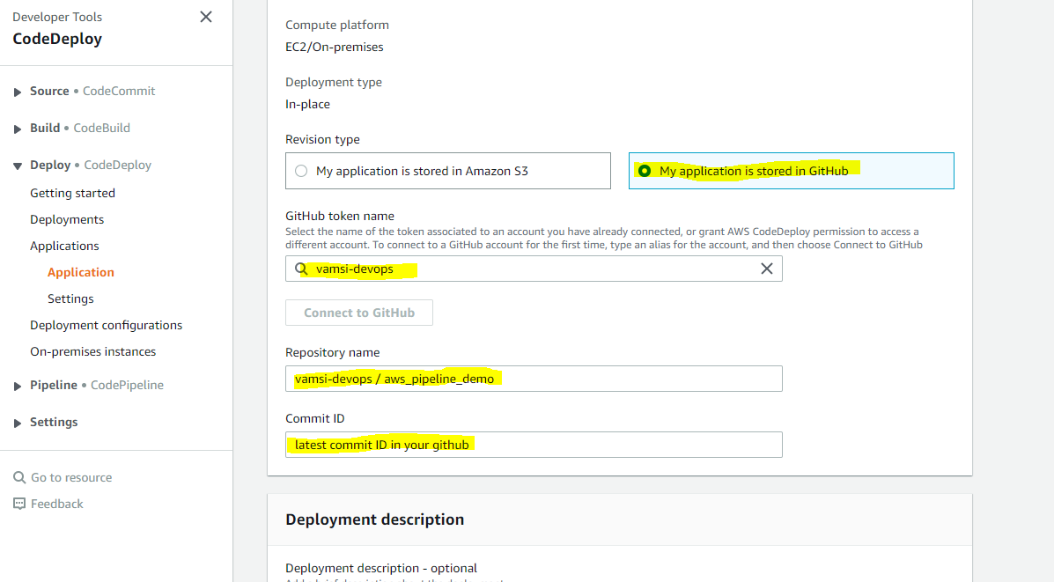

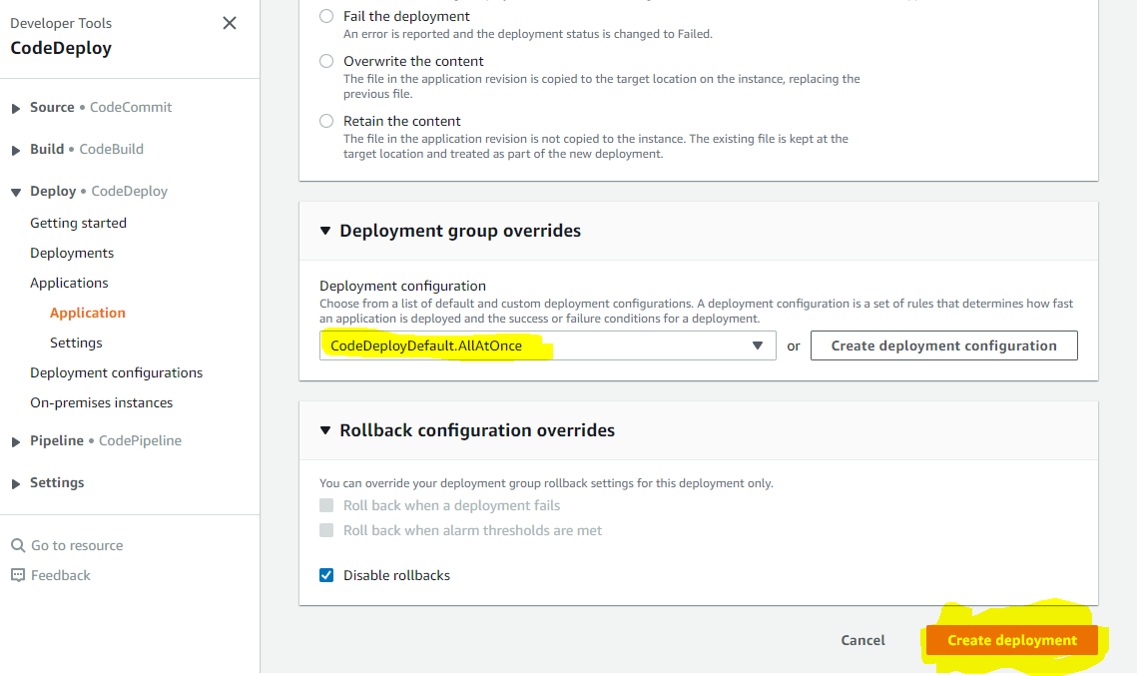
2.4 Code Pipeline:

- Now Create a CodePipeline for one click deployment.
- There are three things in Code pipeline.
1) Source GitHub is linked to Source
2) Code Build buildspec.yml
3) Code Deploy appspec.yml

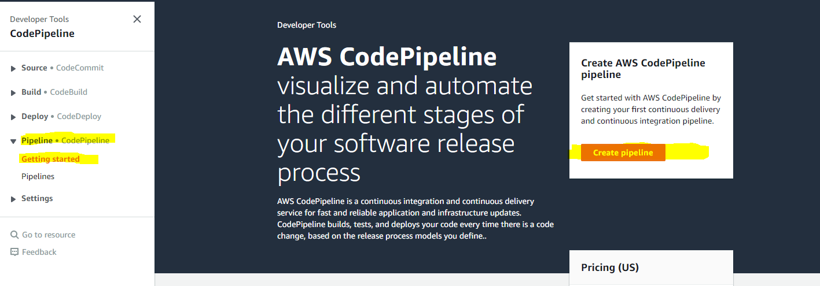

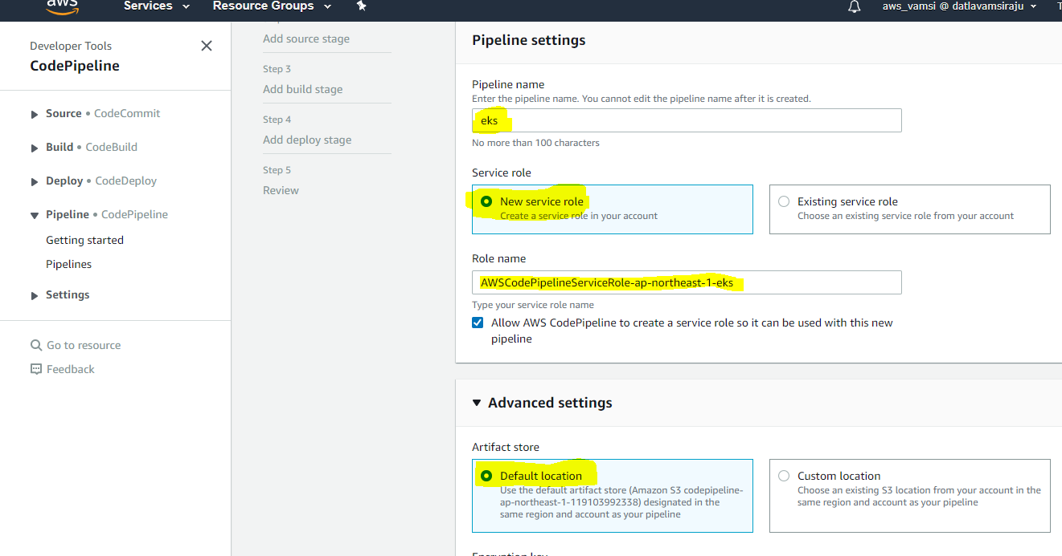

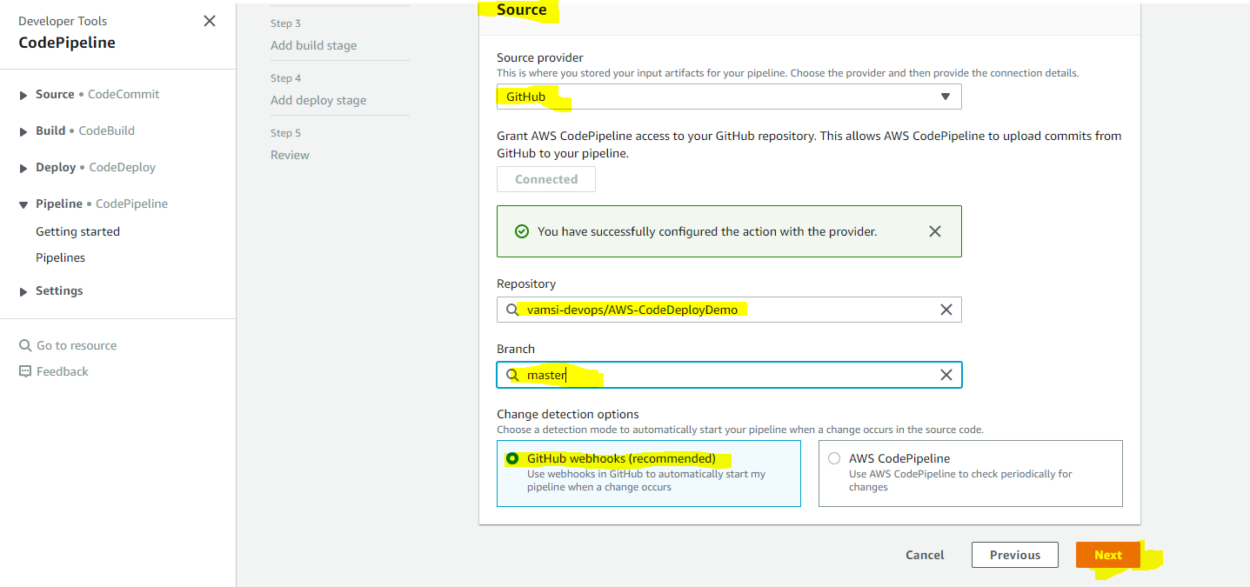

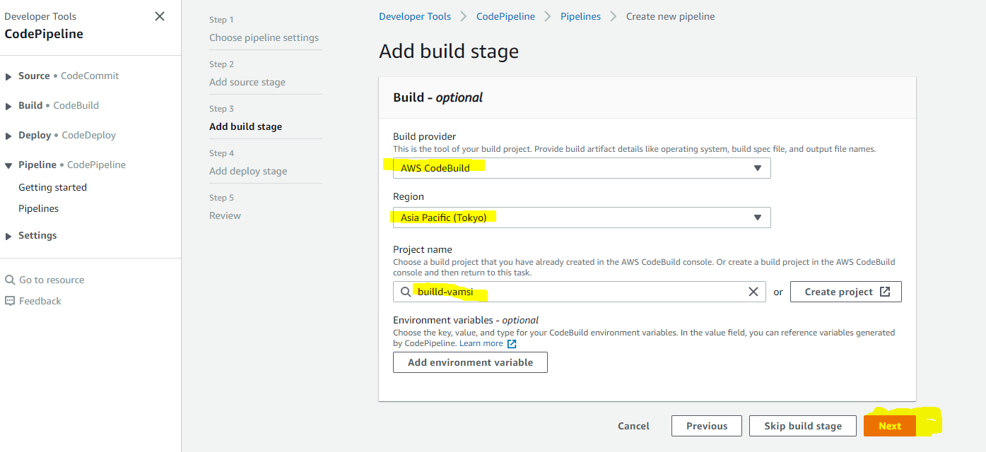

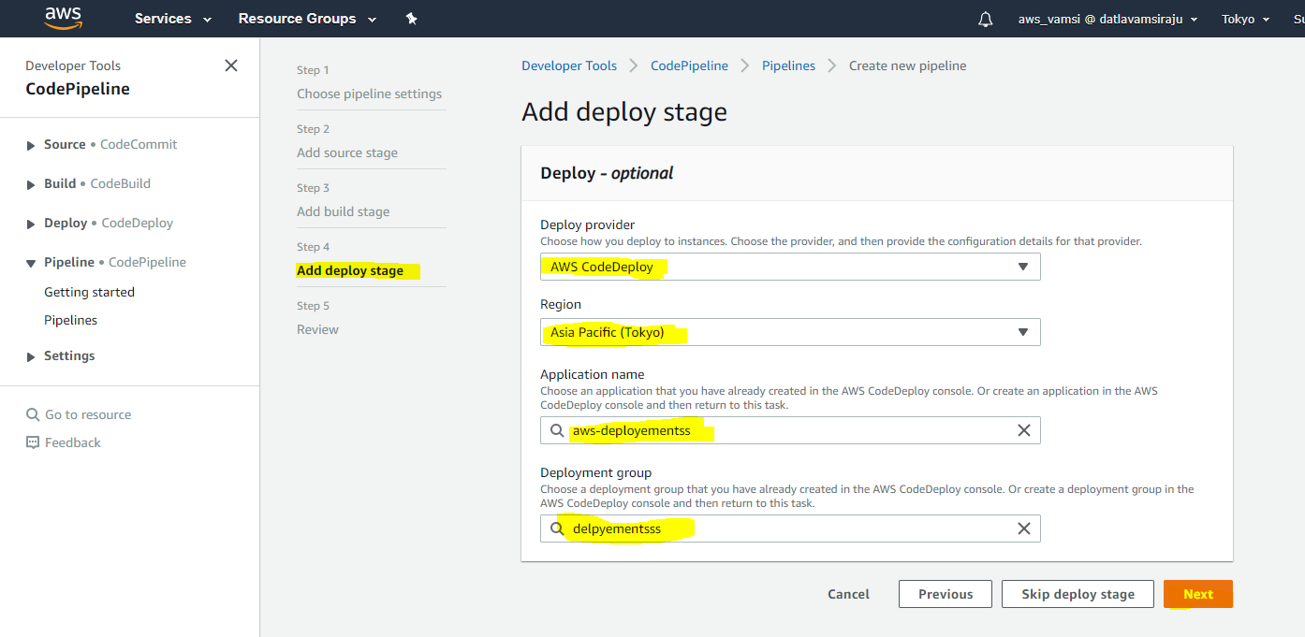

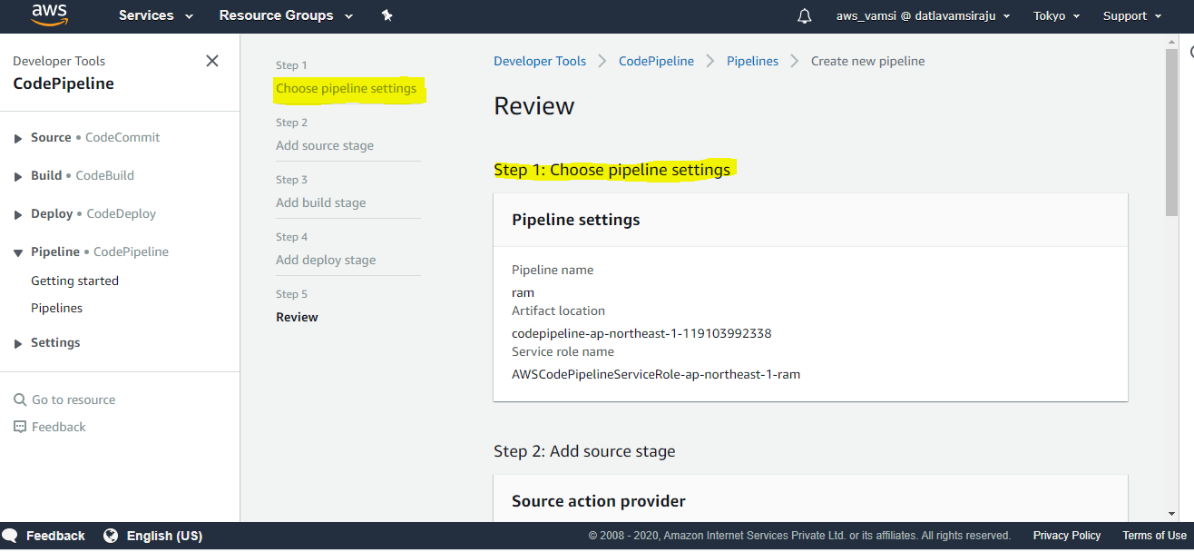

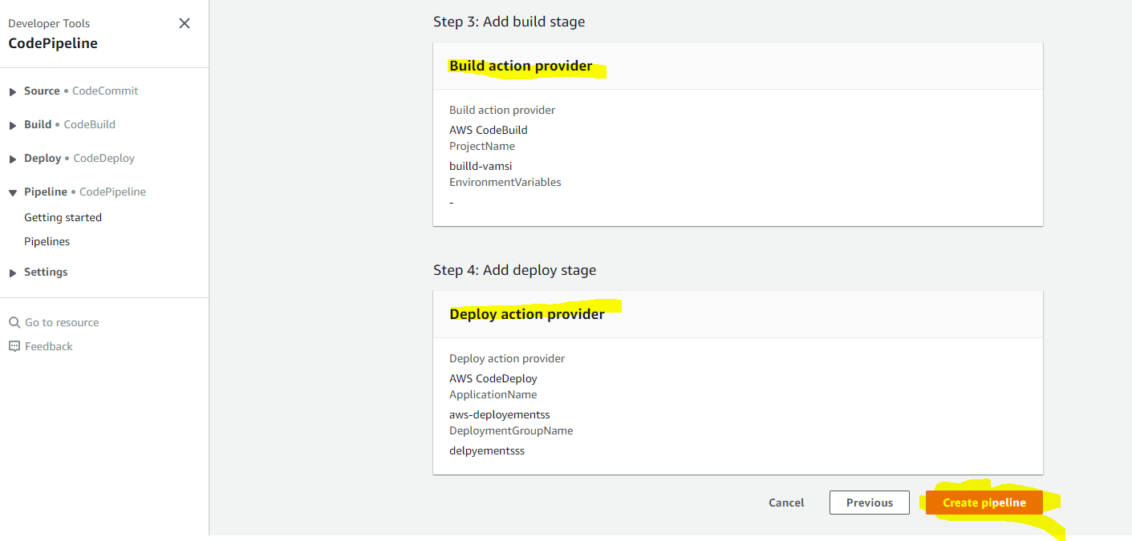

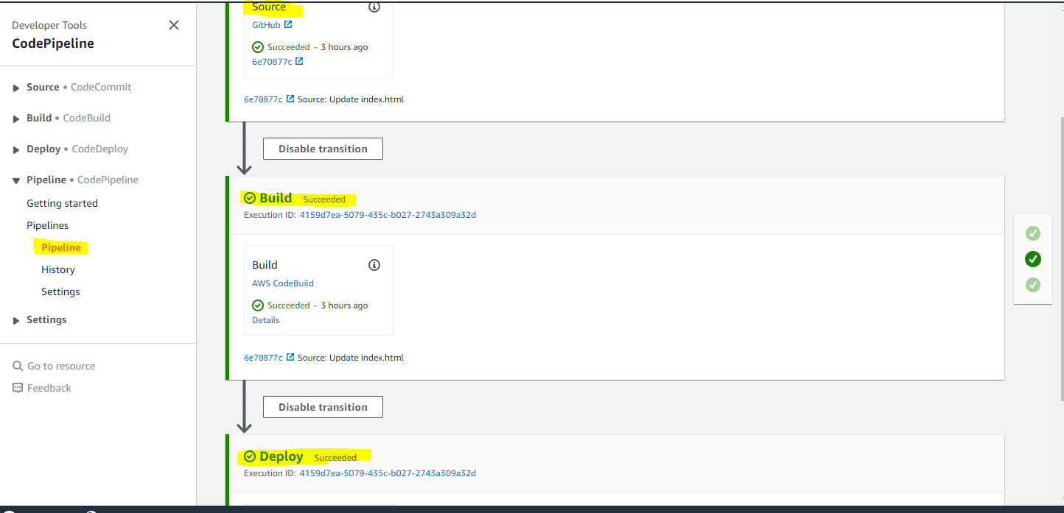

- With the help of below commands we can create a basic-cluster1 these commands are given in appspec.yml.

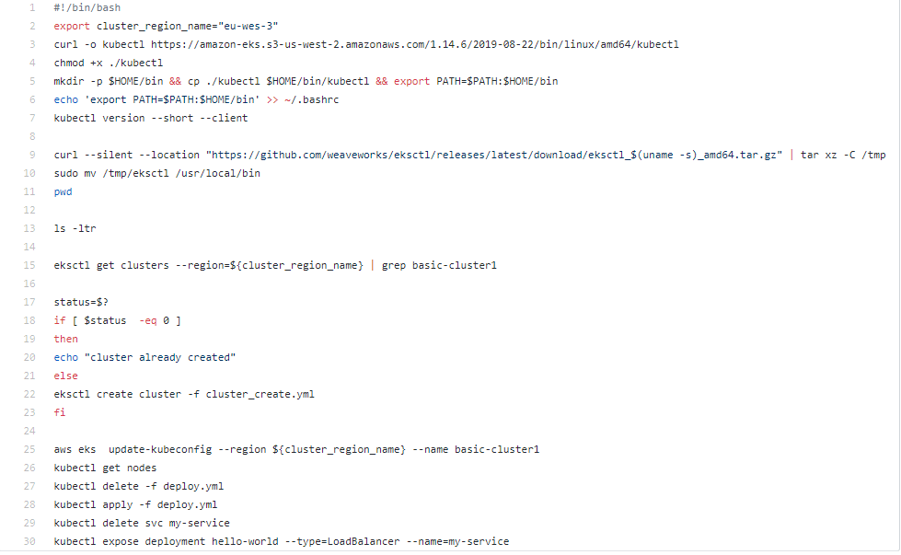
The above commands with the help of appspec.yml it will create an EKS cluster.

2.5 EKS Cluster Formation:

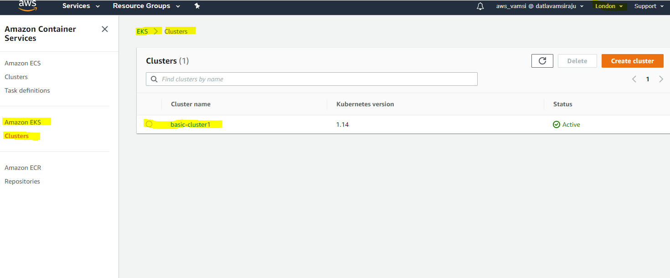

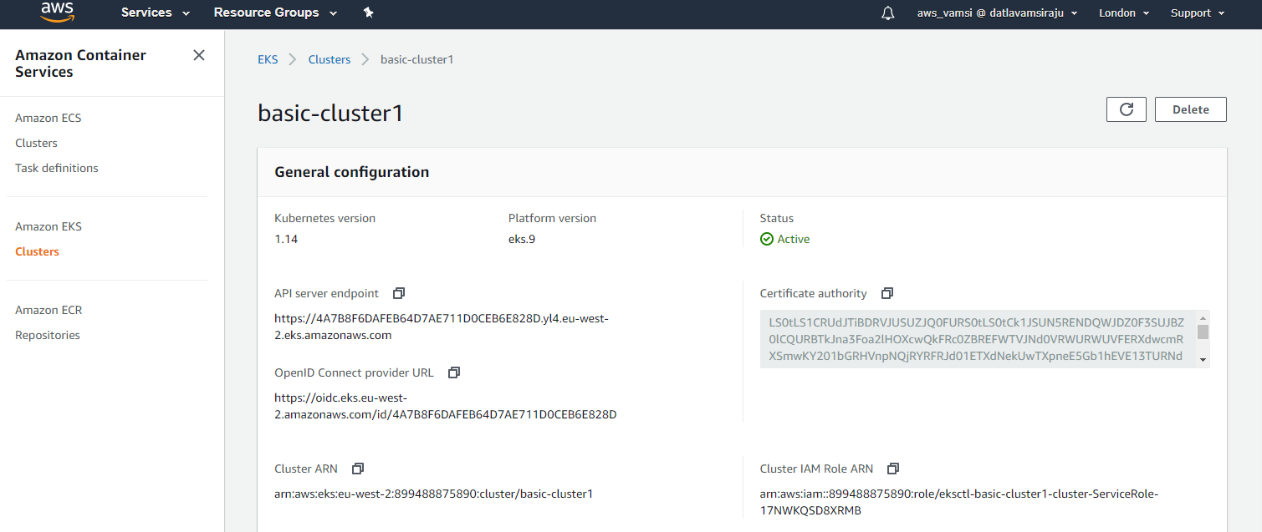

2.6 Output:

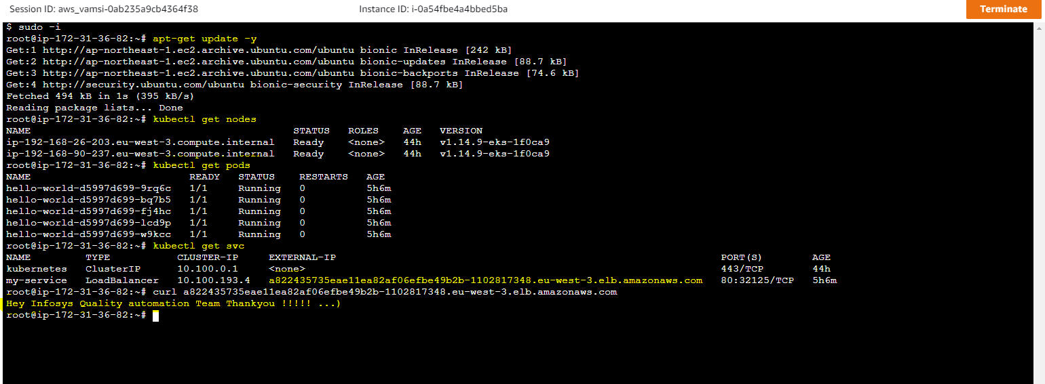

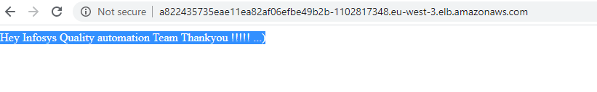
Output with Java Code:

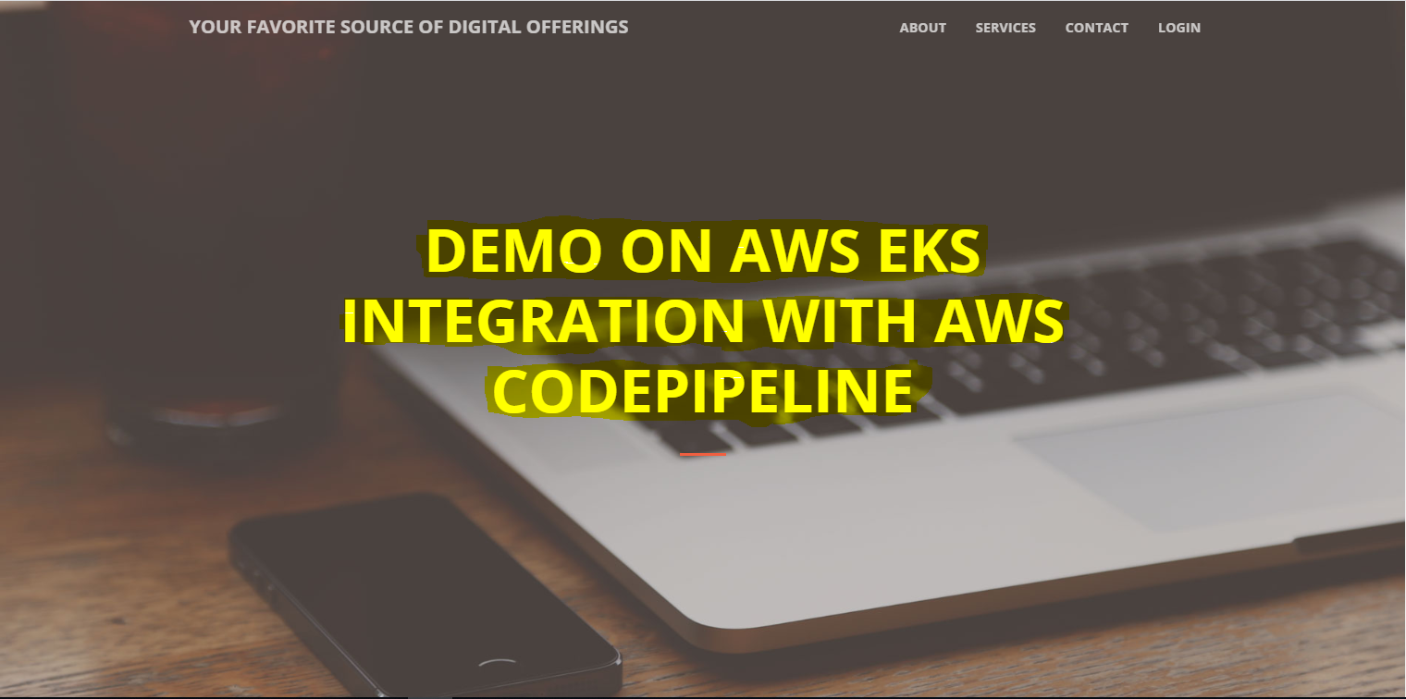

Reference:

https://github.com/vamsi-devops/aws_pipeline_demo

https://www.tothenew.com/blog/aws-codedeploy-and-github/#

https://docs.aws.amazon.com/cli/latest/userguide//install-cliv2-linux.html

https://docs.aws.amazon.com/codedeploy/latest/userguide/codedeploy-agent-operations-verify.html

https://docs.aws.amazon.com/eks/latest/userguide/getting-started-eksctl.html

